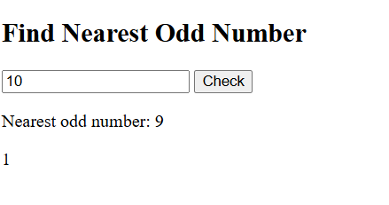
2.Write a Javascript program to get the numbers from the user and display only the nearest odd numbers. 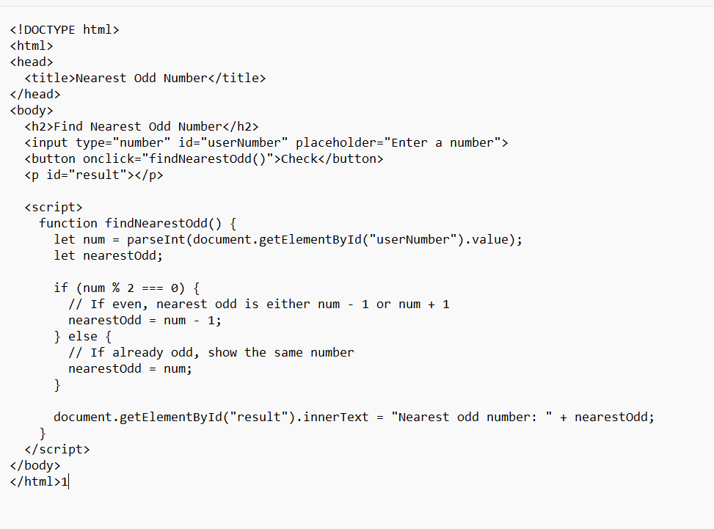output

